<https://www.google.com/url?sa=i&url=https%3A%2F%2Fworld-geography-games.com%2Fnl%2Feuropa.html&psig=AOvVaw2FyMknjYr0MmfwrwtAx7nU&ust=1694780253147000&source=images&cd=vfe&opi=89978449&ved=0CBAQjRxqFwoTCLCPxsmKqoEDFQAAAAAdAAAAABAE>

<https://www.google.com/imgres?imgurl=https%3A%2F%2Fpngimg.com%2Fd%2Fgoogle_maps_pin_PNG62.png&tbnid=IDPgULbE-e-OSM&vet=12ahUKEwiR49mgirSBAxW7hP0HHQTYA7EQMygIegQIARBg..i&imgrefurl=https%3A%2F%2Fpngimg.com%2Fimage%2F110716&docid=9XAYkO67KGUqPM&w=848&h=1280&q=google%20maps%20pin&ved=2ahUKEwiR49mgirSBAxW7hP0HHQTYA7EQMygIegQIARBg>

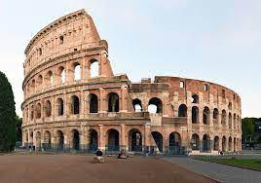

<https://www.google.com/imgres?imgurl=https%3A%2F%2Fupload.wikimedia.org%2Fwikipedia%2Fcommons%2Fthumb%2Fd%2Fde%2FColosseo_2020.jpg%2F1200px-Colosseo_2020.jpg&tbnid=l2qq4cES2qcnPM&vet=12ahUKEwjA07Trj7uBAxWThv0HHTqtASoQMygAegQIARBS..i&imgrefurl=https%3A%2F%2Fen.wikipedia.org%2Fwiki%2FColosseum&docid=oe0sWeScbPME2M&w=1200&h=841&q=colosseum%20rome&ved=2ahUKEwjA07Trj7uBAxWThv0HHTqtASoQMygAegQIARBS>

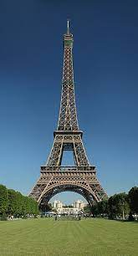

<https://www.google.com/imgres?imgurl=https%3A%2F%2Fupload.wikimedia.org%2Fwikipedia%2Fcommons%2Fthumb%2Fa%2Fa8%2FTour_Eiffel_Wikimedia_Commons.jpg%2F266px-Tour_Eiffel_Wikimedia_Commons.jpg&tbnid=graI5K9qe2zfVM&vet=12ahUKEwiK1dCXlLuBAxVKnf0HHYu5Cx0QMygAegQIARBQ..i&imgrefurl=https%3A%2F%2Fnl.wikipedia.org%2Fwiki%2FEiffeltoren&docid=qCFemhcjuA5YlM&w=266&h=492&q=eiffeltoren&ved=2ahUKEwiK1dCXlLuBAxVKnf0HHYu5Cx0QMygAegQIARBQ>

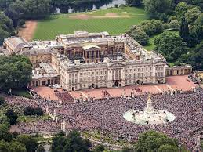

<https://www.google.com/imgres?imgurl=https%3A%2F%2Fupload.wikimedia.org%2Fwikipedia%2Fcommons%2Fthumb%2Fd%2Fd3%2FBuckingham_Palace_aerial_view_2016_%2528cropped%2529.jpg%2F1200px-Buckingham_Palace_aerial_view_2016_%2528cropped%2529.jpg&tbnid=4027zjxKQSMk6M&vet=12ahUKEwiircqumLuBAxVn8rsIHRnpDbIQMygAegQIARBO..i&imgrefurl=https%3A%2F%2Fen.wikipedia.org%2Fwiki%2FBuckingham_Palace&docid=pS4YsoEGpgubkM&w=1200&h=900&itg=1&q=buckingham%20palace&ved=2ahUKEwiircqumLuBAxVn8rsIHRnpDbIQMygAegQIARBO>

Bronnen: Informatie

<https://nl.wikipedia.org/wiki/Colosseum>

<https://nl.wikipedia.org/wiki/Eiffeltoren>

<https://nl.wikipedia.org/wiki/Buckingham_Palace>

Font koppen:

1. Mega Suprise
2. Revamped
3. Choco Bubble

Font tekst:

1. Calibri
2. Ariel
3. Verdana